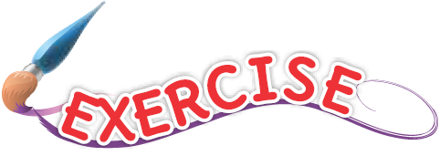
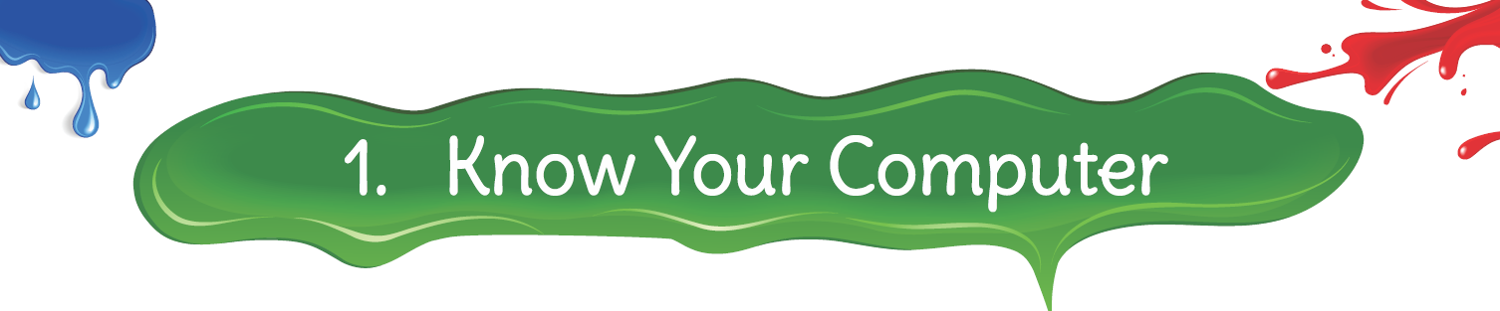

- Name the following:
Ans. 1. Mouse
2. Monitor
3. Scanner
4. Web Scanner
5. Keyboard

II. Rearrange the jumbled words:
Ans. 1. COMPUTER
2. KEYBOARD
3. PRINTER
4. SPEAKERS

- Match the following:

Ans. 1. c 2. d 3. a 4. b

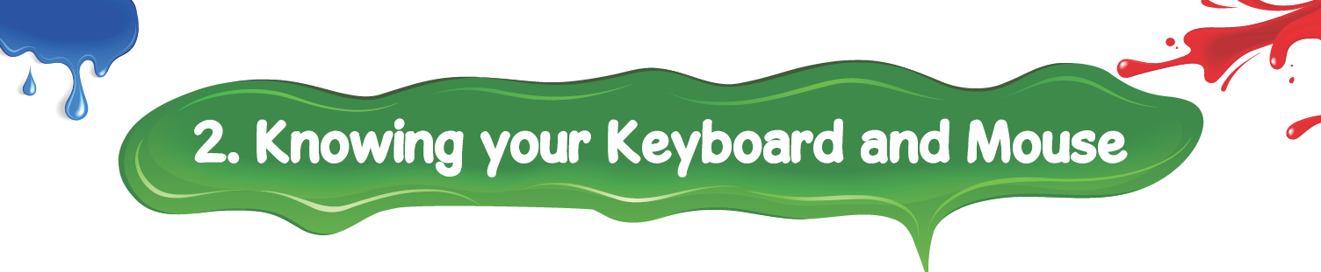

I. Answer the following questions:

1. Write the names of the different types of keys on the keyboard.
Ans. Alphabet keys, Number keys, Special Characters, Navigation keys, Numeric Keypad, Special Keys and Function Keys are the different types of keys on the keyboard.

2. What does the Shift key do?
Ans. Shift key helps us to type capital letters without pressing the Caps Lock key. It also helps us to type special characters on the upper side of some keys.

3. What is the difference between Delete key and Backspace key?
Ans. Backspace key deletes a letter to the left of the cursor and Delete key delete a letter on the right of the cursor.

II. Fill in the blanks:
Ans. 1. Shift key
2. Q, W, E, R, T, Y
3. Function
4. Backspace
5. Delete

- Match the keys with its function:

Ans. 1. b 2. d 3. a 4. c

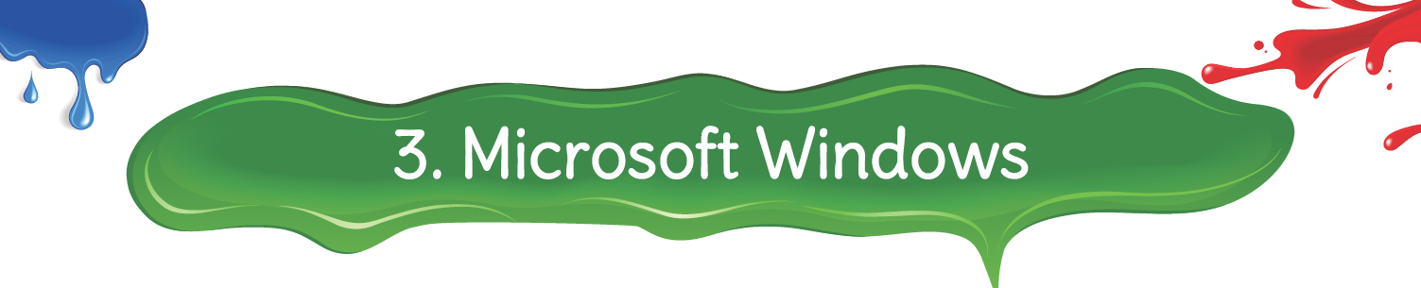

I. Answer the following questions:

1. What is an Operating System?
Ans. An Operating System allows you to work on a computer and controls all the parts of the computer system.

2. What is an Icon?
Ans. Icons are little pictures displayed on the desktop that represent a program, file or folder.

3. What is the use of the Recycle Bin? Why should we empty it often?
Ans. Recycle Bin is like a dustbin in which we can move all the files and folders in our computer that are no longer of use. We must empty the Recycle Bin often to clear the memory space.

II. Complete the steps you would take to shut down a computer:
Ans. 1. Start
2. Power
3. Shutdown

III. Who am I?
Ans. 1. Icon
2. Taskbar
3. Start Button
4. Recycle Bin
5. This PC

IV. Match the Following:
Ans. 1. b 2. e 3. c 4. a 5. d

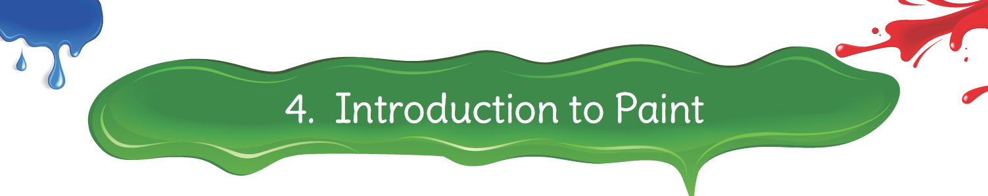

I. Answer the following questions:

1. What is the use of scrollbars?
Ans. The scrollbar allows us to view the unseen part of the Paint canvas.

2. What is a drawing canvas?
Ans. Drawing canvas is the Central part of the screen where pictures are drawn and edited.

3. Name some tools in the Paint Toolbox.
Ans. Pencil, Fill with color, Text, Eraser, Color Picker tool, Magnifier Tool are some tools in the Paint Toolbox.

(Note: Please ask students to hover the mouse on toolbox to see the name of the tools which are not mentioned in this chapter)

II. Fill in the blanks:
Ans. 1. Paint
2. Title
3. Drawing board
4. toolbox

III. Label the parts of the Paint window:

Refer to the ‘Paint Window’ on Page 19.

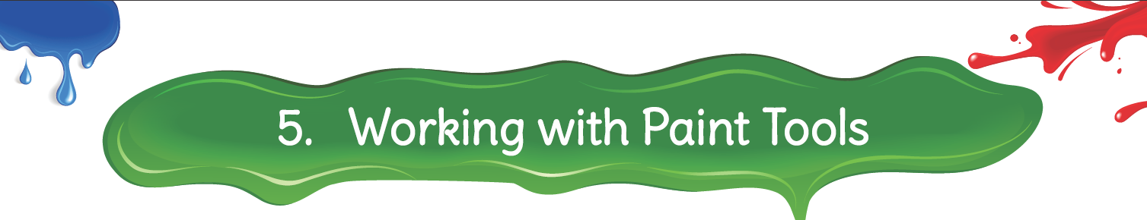

- Match the following:

Ans. 1. c 2. a 3. d 4. b

- Fill in the blanks:
Ans. 1. Pencil
2. Eraser
3. Text

III. Label the following tools on the toolbox:
Ans. Left side Labels: 1. Fill with color
2. Pencil
3. Eraser

Right side Labels: 1. Text
2. Magnifier
3. Color Picker

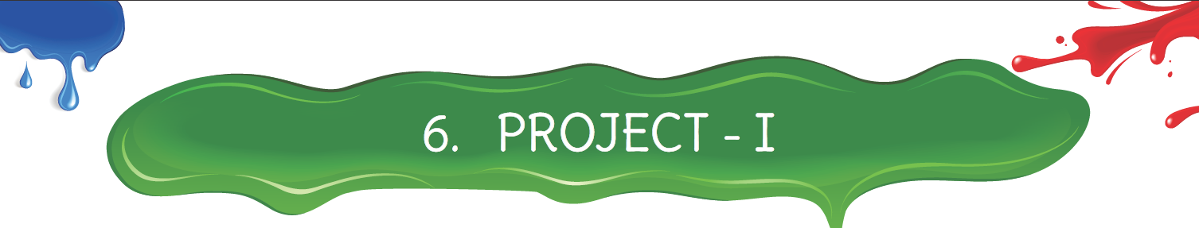

- Who am I?
Ans. 1. Mouse
2. Monitor
3. Printer
4. Enter

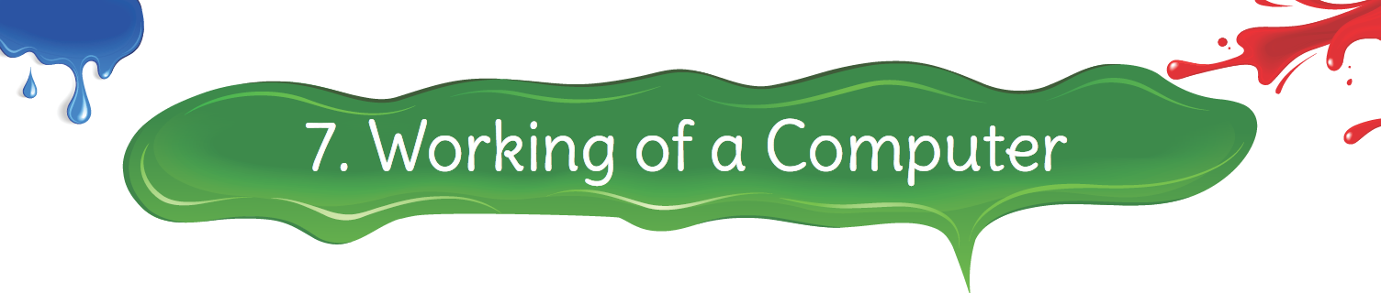

I. Answer the following questions:

1. What are storage devices? Name any three of them.
Ans. This information is stored in the hardware called Storage Devices. Hard Disk, CD / DVD, USB flash drive (Pen Drive) are some storage devices.

2. What is an Input Process Output cycle?
Ans. Computers work on the principle of Input-Process-Output cycle. It accepts the data, processes it and provides the desired output.

II. Fill in the blanks:
Ans. 1. Data
2. Input-Process-Output cycle
3. Storage device / Memory device

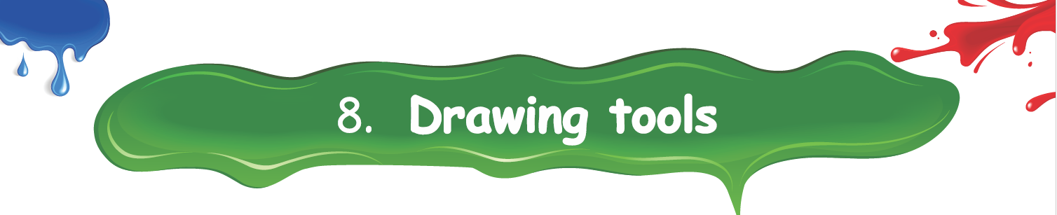

- Fill in the blanks:
Ans: 1. Rectangle
2. Curve
3. Brushes

II. Name the following tools:
Ans: 1. Curve tool
2. Fill color tool
3.Brush tool
4. Eraser tool

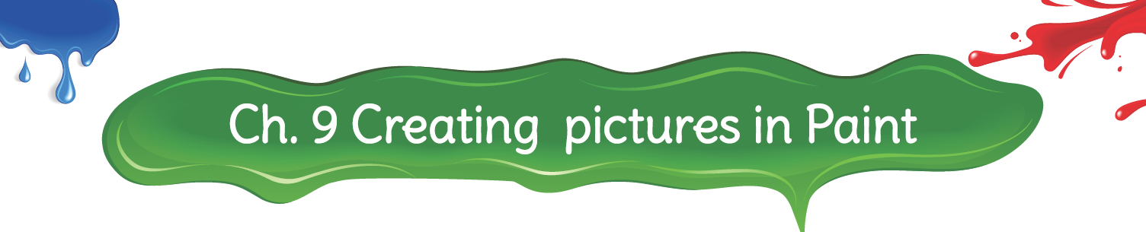

- Tick the correct answer.

Ans: 1. a 2. b 3. b 4. b

- Answer in one word.

Ans: 1. Pencil
2. Rotate

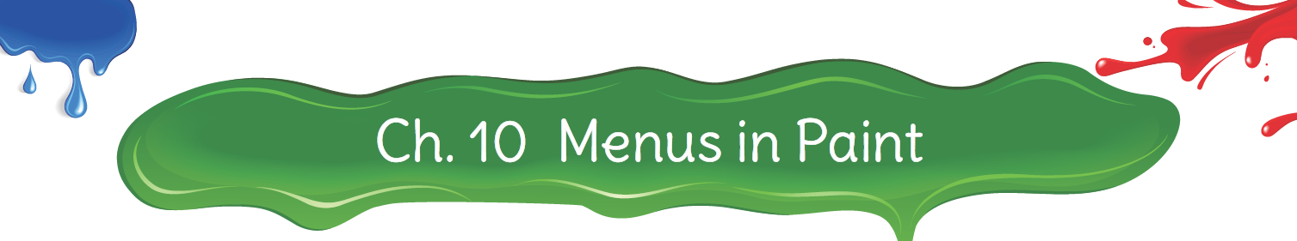

- Complete the options in the given picture.

Ans: New
Open
Save
Print
Print Preview
Send in Email
Undo
Redo

- Name the options available in the menus stated below:

Ans: 1. New, Save
2. Undo, Redo
3. Zoom, Display

(Note : Teacher may please ask students to open the menus stated in the
question and write options of their own choice)
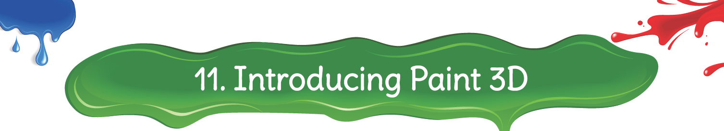

I. Answer the following questions:

1. How to open Paint 3D?
Ans. To open Paint 3D:
1. Click on Start → Paint 3D OR type Paint 3D in Search box
2. Click New tab for a new drawing in the Paint 3D welcome window that opens.

2. Explain Brushes.
Ans. We can select the Brushes tool from the tool bar. Then the mouse changes to the Four-sided arrow and it displays 10 options in the right-side panel. We can select the desired brush and start drawing on the canvas using a mouse. This panel also provides options for controlling Thickness, Opacity, Material and Color.

II. Fill in the blanks:
Ans. 1. Drawing Canvas
2. Rotate tool
3. three

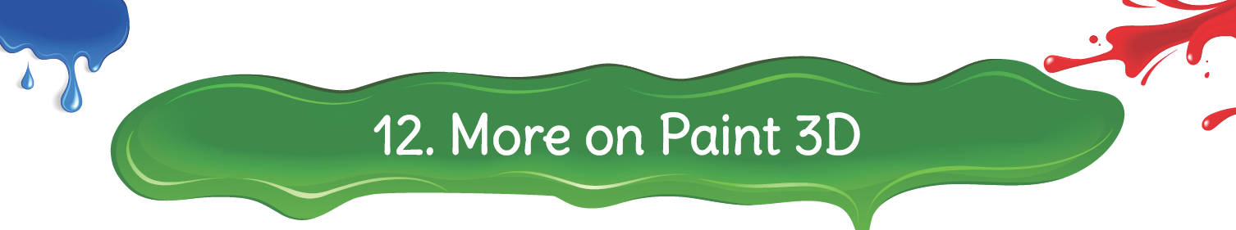

I. Answer the following questions:

1. Explain Cropping Tool.
Ans. The Cropping tool basically creates a new canvas size. The tool will be used to crop a part of the image.

2. How many types of 3D Doodles? Name it.
Ans. There are two different 3D doodle options: Hard edge and Soft edge.

3. What is the use of History Tool?
Ans. The History tool keeps a record of each tool you have used while creating a new Paint 3D model. By moving the History Slider, you can replay the steps you did in creating your drawing.

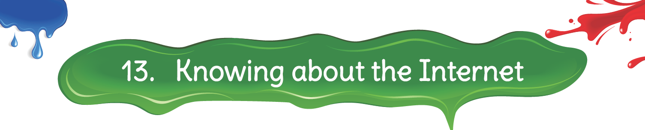

- Answer the following questions:

1. What is the Internet?
Ans. Internet is a huge network connecting millions of computers from all over the world that allow the users to share information and communicate with each other. These computers are connected by means of cables, telephone wires or some wireless media.

2. What is a web browser?
Ans. A Web browser is an application software that we can use to surf the Internet.

II. Fill in the blanks:
Ans. 1. Address bar
2. Microsoft Edge
3. Address
4. World Wide Web

